Assessment in Science

Informing Pupils of Targets:
- On the inside cover of pupils Science books, a target sheet displaying year group objectives for each unit of work, including Working Scientifically statements, is glued in
- In each lesson, pupils are guided towards the relevant targets they will be working on
- This ensures that pupils are accurately informed about the skills and knowledge they will be developing within every lesson and over time as part of a wider unit of work
- Pupils self and peer-assess (where appropriate) against the relevant targets at the end of each lesson

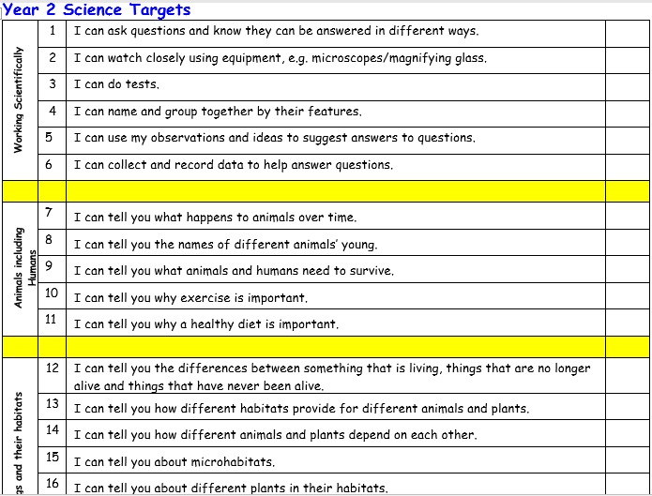

Ongoing Assessment:
- Class Teachers and HLTAs (where appropriate) use a range of Assessment for Learning strategies in order to formatively assess pupils’ achievements and progress within lessons.

Formal Assessment:
- Pupils’ achievements and progress is assessed formally by Class Teachers at the end of each unit of work (once per half term/term depending on the unit of work being studied).
- An assessment spreadsheet is used to minimise unnecessary workload and enable data to be automatically calculated.
- At the beginning of each unit of work, pupils complete a Rising Stars Diagnostic Assessment which tests pupils’ retention of relevant prior knowledge. These diagnostic assessments are glued into pupils Science books following the relevant knowledge organiser and unit title page
- Class Teachers use the Rising Stars Progress Tracker spreadsheet in order to input the results of pupils’ diagnostic assessments
- Results for each question are inputted in order to identify gaps in knowledge and further teaching points for which Class Teachers will amend future lesson planning and delivery
- At the end of each unit of work, pupils also complete a Rising Stars End of Unit Assessment which tests pupils retention of the key knowledge taught and developed over the course of the unit of work
- The assessment spreadsheet automatically colours codes each individual pupil’s performance, identifying pupils Working Towards ARE, Working at ARE and Working at Greater Depth

Working Towards ARE | A score of 0-5 out of a possible 10 marks
Working at ARE | A score of 6-8 out of a possible 10 marks
Working at Greater Depth | A score of 9-10 out of a possible 10 marks

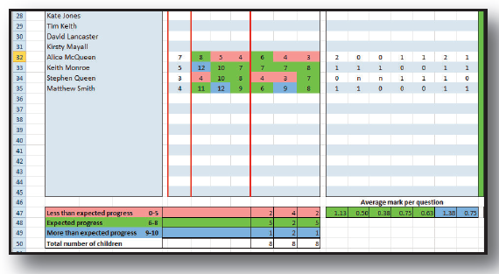

- The Rising Stars Progress Tracking spreadsheet is also used to automatically generate individual pupil reports which provide a summary of pupils’ performance over time within specific units of work and also over the course of the year-long programme of study

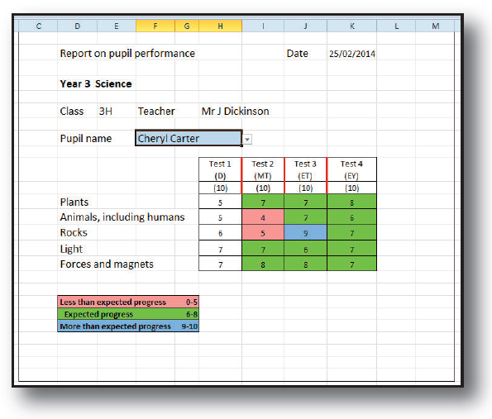

Reporting and Tracking:
- Class Teachers share completed assessment spreadsheets with the Subject Leader and Curriculum Lead (DHT) at the end of each unit
- The data submitted is analysed by Leaders in order to identify trends and areas for further development

Moderation:
- Non-Core assessment data is reviewed termly by Subject Leads, the Curriculum Lead and SLT and is subject to internal moderation.
- Class teachers discuss the attainment and progress of pupils in all non-core subjects at termly Pupil Progress meetings with members of SLT.

